The NBA is the most competitive basketball league in the world. New players enters the league through a draft system which awards teams who do poor a greater chance of getting and keeping young talent. As a result, a great deal of focus is awarded to player selection. In recent years, a lot of work has been done through statistical analysis to determine which individuals would contribute the most to a team’s success. We decided that we would like to use statistics to take a slightly different approach. There are two significant factors which do not come to mind as often because teams cannot or should not be able to control: refereeing and fans. We believe that these two variables should be considered because, even though teams cannot affect them directly, they can change how they react to them.

Refereeing has always been a significant debate within the NBA. Fans, players and coaches often disagree with calls and notice inconsistencies between officials. Even though a team cannot control refereeing, if trends exist in the severity of officiating, they can use this information to their advantage. We used a Kaggle dataset that had box scores starting in 2012 and covering 7 seasons. The data contained the referees who called each game as well as the number of fouls called against each team. The which referee blew the whistle for each given call was not specified. We made the decision that we will attribute the total number of fouls called per game to all referees. This was decided based on how the NBA rulebook notes officiating should be conducted. Under Section IV, *Different Decisions By Officials*, of Rule NO.2: *Duties of the Officials* it is stated that in many situations where a referee disagrees with a call made by their colleague they can “conference” to reach a ruling. This implies that all three referees are responsible for foul calls either by blowing their whistle or deciding that their colleague made the correct decision.

The first step was to look at the average number of fouls called by each referee. We wanted to see if there was a significant discrepancy between their numbers. They should be fairly similar because all officials get the opportunity to referee all teams. To make sure outliers were not present because of referees who had very few games under their belt, we removed all those who officiated fewer than 82 games. We believed this to be a sufficient number of games because each official would have had the opportunity to interact with the majority of the teams and experience games of diverse intensities. This would also imply that each of the referees analyzed have been in the NBA for at least on whole season.

Graph 1: The graph below displays the average number of fouls called by each referee per game.

Section A of the appendix contains the referees who are represented by each number.

The referees with numbers 1 and 2 are Aaron Smith and David Jones and they seem to be some of the more lenient officials. On the other hand, Scott Foster is one of the strictest as he is number 72. We were encouraged by our findings since this article discusses how NBA players do believe Scott Foster is one of the strictest referees in the league.

Looking at the graph we can see that the average fouls called per game by referee ranges from around 38 to 42 displaying a 10% difference in decision making. There seems to be about a 2-foul divergence from the mean. If we are conservative and assume that these are generally fouls within the 3-point arc, this discrepancy can cause up to a 4-point increase in a team’s score. This is significant because out of the 14,758 games analyzed 3046 of them, or almost 21%, end in a point differential of less than 4 points. As a result, more than one-fifth of the games would have or could have (in the case of a tie) had a different outcome.

Graph 2: The graph below displays how many NBA games have ended by a given point differential.

The blue bars represent the number of games that have ended in 1- or 2-point differentials, meaning that the outcome could have been changed by an extra foul call. The orange bars display games that have ended in 3- or 4-point differences whose final result could have been modified by two fouls.

Graph 1 allows us the observation that there are differences between officiating that can be exploited by teams. The next step was to standardize this on a team by team basis. This was done by first looking at the average number of fouls each referee calls against a specific team. Once again, to limit the effect of outliers, we removed all the data from all referees who officiated less than 20 games of a specific team. We also limited our graphs to look at the referees who were in the eighth decile in terms of the average number of fouls called or in the bottom 20%. This helped make the graphs easier to view and outlined the extremes.

Graph 3: The average number of fouls called against a team by referee.

We then went a step further and looked to see if there is any sort of bias that teams can exploit. As a result, we began looking to see if certain referees call less or more fouls against a team than the usually call. Once again, we limited our graphs to look at the referees who were in the eighth decile in terms of the average number of fouls called or in the bottom 20%. We did this by graphing the difference between the mean number of fouls for that referee and the number of fouls they called against a specific team. Of course, it is to be expected that if a team fouls a lot that the majority of the referees would also call more fouls against this team than they do in general. The data becomes interesting when referees do the opposite, meaning that they deviate from their normal refereeing in the opposite direction.

The graphs for the remaining teams can be found…

Graph 4: The difference between the average number of fouls called by a referee and the average number he calls against a specific team. A negative value means they call more fouls on average against the specific team than their overall average.

For example, the Phoenix Suns are the team with the highest number of fouls called against them since 2012. Normally, this would mean that the majority, if not all, of the referees would call more fouls against them than they do on average. Interestingly, three referees, Ed Malloy, Ron Garretson and Brian Forte call fewer fouls against the Suns than they do in general. This is not to insinuate that they are biased and unfair. It is possible that over the games officiated by these referees, Phoenix was not as aggressive. On the other hand, we do believe that it would benefit teams such as the Suns to look back at the games officiated by these three and determine if it did happen to be chance, or if there is an underlying bias that can be exploited.

As an extension we decided to look free-throw shooting percentages differ based on the location of the game. We thought this was a logical progression because our argument is that differences in officiating can help a team earn more opportunities to shoot free throws or prevent their opponents from doing so.

Graph 5: The free-throw shooting percentage based on who the home team was. The x-axis contains the home team while the y-axis displays the free-throw shooting percentage of opponents.

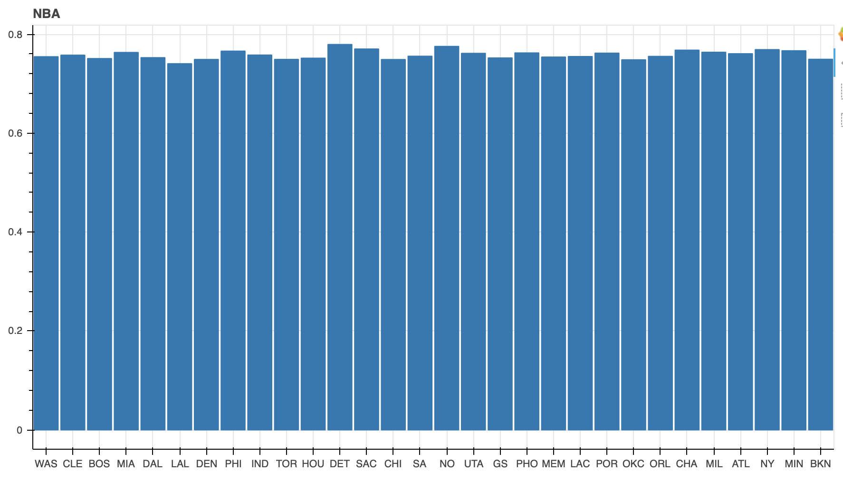

This graph is useful because it can help us calculate the expected value of a free-throw at a certain location. We can therefore make a more accurate prediction as to whether committing a foul or trying to earn a foul will help us reach a more favorable outcome. This graph can also be expanded such that we have team by team data as we did in the case for fouls. We decided that this was not as useful because players move from team to team which can affect the results. What would be really useful as a continuation would be to graph this result on a player by player basis. This would help a coach decide which players should be fouled or what players should be put in a position where they could earn a foul based on the location of the game.

Overall, the purpose of our investigation was to determine if NBA teams can or should take into account referees and game location. We believe the answer is yes and that keeping these two variables in mind can lead to better decision-making. Knowing the strictness of a referee should help model a game plan. A referee squad who is lenient and who may even have a positive bias towards your team could determine you to be more aggressive. This coupled with the knowledge that a certain team has a lower than usual free-throw percentage in the location that you are playing in could help structure a more personalized plan on defense.

Appendix:

1. The following are the referees represented by each number on the x-axis of graph 1.

"1) Aaron Smith" "2) David Jones" "3) Ron Garretson"

"4) Eric Dalen" "5) Marc Davis" "6) Gediminas Petraitis"

"7) Kevin Fehr" "8) Ed Malloy" "9) Derrick Stafford"

"10) Jason Phillips" "11) Kevin Scott" "12) Brian Forte"

"13) Dan Crawford" "14) Dedric Taylor" "15) Ken Mauer"

"16) Brent Barnaky" "17) Haywoode Workman" "18) Jacyn Goble"

"19) Pat Fraher" "20) Eli Roe" "21) Olandis Poole"

"22) Mike Callahan" "23) Leon Wood" "24) Dick Bavetta"

"25) Joe Crawford" "26) Mark Lindsay" "27) Courtney Kirkland"

"28) Derek Richardson" "29) Sean Corbin" "30) Rodney Mott"

"31) J.T. Orr" "32) Derrick Collins" "33) James Williams"

"34) Bill Spooner" "35) Curtis Blair" "36) Brett Nansel"

"37) Leroy Richardson" "38) Scott Twardoski" "39) David Guthrie"

"40) Tony Brown" "41) Tony Brothers" "42) C.J. Washington"

"43) Tre Maddox" "44) Marat Kogut" "45) Karl Lane"

"46) Violet Palmer" "47) Scott Wall" "48) Mark Ayotte"

"49) Nick Buchert" "50) Tom Washington" "51) Lauren Holtkamp"

"52) Kevin Cutler" "53) Gary Zielinski" "54) Bill Kennedy"

"55) Bennett Salvatore" "56) Monty McCutchen" "57) John Goble"

"58) Steven Anderson" "59) Josh Tiven" "60) Eric Lewis"

"61) Kane Fitzgerald" "62) Ben Taylor" "63) Matt Boland"

"64) Bennie Adams" "65) Tyler Ford" "66) Sean Wright"

"67) Justin Van Duyne" "68) Michael Smith" "69) Zach Zarba"

"70) James Capers" "71) Mitchell Ervin" "72) Scott Foster"

1. Team Abbreviations
   1. ATW – Atlanta Hawks
   2. BKN – Brooklyn Nets
   3. BOS – Boston Celtics
   4. CHA – Charlotte Hornets
   5. CHI – Chicago Bulls
   6. CLE – Cleveland Cavaliers
   7. DAL – Dallas Mavericks
   8. DEN – Denver Nuggets
   9. DET – Detroit Pistons
   10. GS – Golden State Warriors
   11. HOU – Houston Rockets
   12. IND – Indiana Pacers
   13. LAC – Los Angeles Clippers
   14. LAL – Los Angeles Lakers
   15. MEM – Memphis Grizzlies
   16. MIA – Miami Heat
   17. MIL – Milwaukee Bucks
   18. MIN – Minnesota Timberwolves
   19. NO – New Orleans Pelicans
   20. NY – New York Knicks
   21. OKC – Oklahoma City Thunder
   22. ORL – Orlando Magic
   23. PHI – Philadelphia 76ers
   24. PHO – Phoenix Suns
   25. POR – Portland Trail Blazers
   26. SAC – Sacramento Kings
   27. SA – San Antonio Spurs
   28. TOR – Toronto Raptors
   29. UTA – Utah Jazz
   30. WAS – Washington Wizards